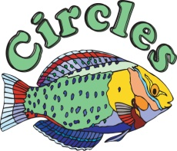
Booking Form
Thank you for booking your event at Circles! To confirm we have all the details for your day correct please verify the following information and sign below.
Event Date: |  | Timing:
Contact Name:
Contact #: |  | Email Address:
Occasion: |  | # of Guests:
Room Hired: |  | Hire Fee:
(20% Gratuity and 7% Tax is not included in the room charge.)
Menu Confirmation: There is a minimum average spend of $__ per person required for all private events ($16 per person at lunch and $32 per person at dinner)
Parties that are pre-ordering can create a limited menu of 3 Appetizers, 5 Entrées and our entire Dessert Selection
For Limited Menus that are ordering on the night options can include 3 Appetizers, 4 Entrées, and 2 Desserts
PLEASE NOTE: All pre-orders must be confirmed at least 7 days before the event

Appetizers ($/H)
1.
2.
3.

Entrées ($/H)
1.
2.
3.
4.
5.

Desserts ($/H)
You are very welcome to bring in your own dessert, our cake cutting fee is priced at $1.50 per person.
1.
2.

Drinks
You are very welcome to bring in your own wines, our corkage fee is priced at $15.00 per 750ml bottle.
- Welcome Drinks
- Drinks on Table
- Bar Tab
- Other

Special Arrangements: (Table Décor, Entertainment, Surprises)

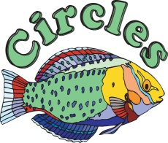
FEES
Hire Fee
Food Cost
Drink Cost
Corkage/Cutting
Special Arrangements
Total
Tax (7%)
Gratuity (20%)
Grand Total
Total due to Confirm
Total due on the Night

Terms and Conditions
- The deposit to confirm the event is non-refundable
- Credit card information will be kept on file until after the event
- Any damages or outstanding payments will be charged to the credit card on file
- In the event the minimum spend is not met the difference will be charged to the card on file
- Circles will notify the card holder of any outstanding charges before they are applied to the card on file

Signature: ______________________________________________ Date: ____________

Circles Contact: Jamila Brown
Info@circleswaterfront.com
813 641 3275

